

Annual Conference
21-23 July 2026
University of Leeds

Tuesday 21st July ................................................................................................................................................................................................................................................... 2
Wednesday 22nd July ............................................................................................................................................................................................................................................. 3
Thursday 23rd July ................................................................................................................................................................................................................................................. 6
General information ............................... ................................................................................................................................................................................................................. 12
Conference locations ............................................................................................................................................................................................................................................... 16
Information for speakers ......................................................................................................................................................................................................................................... 17
Accessibility information ........................................................................................................................................................................................................................................ 18
Presidential Address ............................................................................................................................................................................................................................................... 19
Keynotes ................................................................................................................................................................................................................................................................. 20
Notes ....................................................................................................................................................................................................................................................................... 21

Tuesday 21st July

11.00-12.00 | BSPS Executive Committee Meeting (Committee only) (G.02)
12.00-14.00 | Graduate Student Workshop (G.02)
14.00-14.15 | Break
14.15-15.15 | BSPS Annual General Meeting (G.02)  Agenda & Hybrid Meeting Link
15.00-15.45 | Coffee (1.32)
15.45-16.00 | Welcome (G.02)
16.00-17.30 | Presidential Address: Robin Hendry (G.02)  Metaphysics and Science: A Call for History  Chair: James Ladyman  Live Streaming Link
17.30-19.00 | Drinks Reception (1.33)

Wednesday 22nd July
08:30-09:30 | Morning Coffee (1.32)

09:30  -  11:00 | Stream 1  1.03 | Stream 2  1.04 | Stream 3  1.05 | Stream 4  1.06 | Stream 5  1.09 | Stream 6  G.02
09:30  -  11:00 | Contributed | Symposium | Symposium | Symposium | Symposium | Symposium
09:30  -  11:00 | General philosophy  of science 1 | Norms in mental health | Sex, Ancestry and Diversity | AI meets molecules | “Good enough” science | Time’s arrow
09:30  -  11:00 | Chair: Mariona Miyata-Sturm | Chair: Zaza Doborjginidze | Chair: Kal Kalewold | Chair: James Ladyman | Chair: Ellen Clarke | Chair: Helen Beebee
09:30  -  11:00 | Emma Braccini  The Pragmatic Dimension of Scientific Understanding: Understanding-for Climate Extremes | Harriet Fagerberg  Sam Wilkinson  Sera Schwarz  Sebastian Rodriguez Duque | Marina DiMarco  Mia Miyagi  Lauren Wilson | Francesca Bellazzi  Fintan Mallory  Vanessa Seifert  Mel Andrews | Stephen John  Mathias Frisch  Katherine Furman  Torbjørn Gundersen  Hannah Hilligardt | Athamos Stradis  David Papineau  Saakshi Dulani
09:30  -  11:00 | Chryssi Malouchou  Identifying heuristic indispensability - deployment realism and different kinds of ‘indispensabilities’
09:30  -  11:00 | Mason Majszak  The Amalgamation of Evidence in Deeply Uncertain Contexts

11:00-11:30 | Coffee (1.32)

11:30-13:00 | Keynote: Tarja Knuuttila (G.02)  Revisiting Artefactualism: The Model-Target Coupling Displaced  Chair: Kirsten Walsh (Live Streaming Link)

13:00-14:00  13:10-14:00 | Lunch (1.32 and 1.33)  BJPS Meet the Editors Session (1.31 NOTE ROOM CHANGE)

14:00  -  15:30 | Stream 1  1.03 | Stream 2  1.04 | Stream 3  1.05 | Stream 4  1.06 | Stream 5  1.09 | Stream 6  G.02
14:00  -  15:30 | Contributed | Contributed | Contributed | Contributed | Contributed | Contributed
14:00  -  15:30 | General philosophy  of science 2 | Philosophy of  the physical sciences 1 | Philosophy of  the life science 1 | Philosophy of  the cognitive sciences 1 | Formal philosophy  of science 1 | Integrated HPS 1
14:00  -  15:30 | Chair: Anqi Wang | Chair: James Read | Chair: Margarida Hermida | Chair: Ali Boyle | Chair: Juha Saatsi | Chair: Adrian Currie
14:00  -  15:30 | Johannes Nyström  Globalizing the no miracles argument | Toby Friend  Is there a Theory of Everything? | Danny Davis  Procedural Objectivity and the Aims of Conservation | Joshua Kramer  & Mara McGuire  Does everyone know what addiction is? | Julien Dutant  Measuring Reliability | Patric Harting  Blind Peer Review with Accountability: A Game-Theoretic Approach
14:00  -  15:30 | Benjamin Santos Genta  No Reproducibility for Systematic Reviews? No Problem. | Alexander Franklin  Against Rigour: In Favour of Informal Standards for Reduction in Philosophy of Physics | Zaza Doborjginidze  The Organizational Account of Biological Functions is a Dispositional Account of Biological Functions | Yinzhu Yang  Analog and Digital Representation Reconsidered: A Network-Based Approach to Cognition-Perception Border | Tobia Fogarin  Reconciling Epistemic Utility Theory and Truthlikeness: An Alternative to Proximity | Kirsten Walsh  Navigating Agential Distance: Margaret Cavendish on the Pitfalls of Experimentation
14:00  -  15:30 |  |  | Francisco Navarro  Ecological units as moral patients: challenges to ecological health | Charlotte Skye  Why the Evidence-Resistance Criterion Fails as a Scientific Marker of Delusion | Ina Jäntgen  When broken is not worth fixing: a decision-theoretic approach to adjusting effect sizes for meta-biases | Srijan Butola  Personal Identifiers - How the Social and the Political Matter for Data-Intensive Health Research

15:30-16:00 | Coffee (1.32)

16:00  -  17:30 | Stream 1  1.03 | Stream 2  1.04 | Stream 3  1.05 | Stream 4  1.06 | Stream 5  1.09 | Stream 6  G.02
16:00  -  17:30 | Contributed | Contributed | Contributed | Contributed | Contributed | Contributed
16:00  -  17:30 | General philosophy  of science 3 | Philosophy of  the physical sciences 2 | Philosophy of  the life science 2 | Philosophy of  the cognitive sciences 2 | Science and values 1 | Philosophy of AI 1
16:00  -  17:30 | Chair: Tarja Knuuttila | Chair: Benjamin Conover | Chair: Ludo Schoenmakers | Chair: Fintan Mallory | Chair: Anjan Chakravartty | Chair: Nick Makins
16:00  -  17:30 | Yuyou Wu  Reconciling Artifactualism and Representationalism: An Enactive Account of Scientific Models | Jonathan Bain  The Explanatory Role of Entanglement Wedge Reconstruction in the Black Hole Information Loss Paradox | Rebecca Riccardo Cuciniello  Plasticity is a Blind Spot in Contemporary Theories of Biological Agency | Ali Boyle  Animals, mental time travel and the harm of death | Alexander Christian  Silent moral complicity in science governance | Antoni Antoszek  The Entropic Self: A Stochastic-Selective Architecture for Artificial Agency
16:00  -  17:30 | Martin Voggenauer  Naturalized Grounding and the Fate of Causal Exclusion | Jonathan Fay  Whence the desire to close the universe | Patrick McGivern  Transitions in biological individuality and mesoscale structure | Scott Partington  From Bad to Wrong: The Origins of Deontic Cognition | Hanna Metzen  Science PR, communicative goals, and trust in science | Henry Weatherburn  From Radiological Protection to Artificial Intelligence: A Transferable Paired-Value Ethical Framework for Governing High-Stakes Technologies
16:00  -  17:30 | Ziren Yang  Surrogative Reasoning under Referential Indeterminacy |  | Rebecca C. Mann  Metabolic Wholes: The Organism as Having a Centred Metabolic Network | Rebeca Mendez  The Gut-Microbiome-Brain Heterarchy: Distributed Regulation and Explanatory Topology | Charlotte Constanze Poller  Between Thickness and Comparability: Measurement Drivers in Global Well-Being Metrics | Molly Powell  Norm Entrenchment Through Algorithmic Transparency and Radical Republicanism

19:00-21:00 | Conference Dinner, Akmal’s

Thursday 23rd July
08:30-09:30 | Morning Coffee (1.32/1.33)

9:30  -  11:00 | Stream 1  1.03 | Stream 2  1.04 | Stream 3  1.05 | Stream 4  1.06 | Stream 5  1.09 | Stream 6  G.02
9:30  -  11:00 | Contributed | Contributed | Contributed | Contributed | Contributed | Contributed
9:30  -  11:00 | General philosophy  of science 4 | Philosophy of  the physical sciences 3 | Philosophy of  the life science 3 | Philosophy of  the cognitive sciences 3 | Formal philosophy  of science 2 | Integrated HPS 2
9:30  -  11:00 | Chair: Lina Jansson | Chair: Neil Dewar | Chair: Ellen Clarke | Chair: Charlotte Skye | Chair: Ina Jäntgen | Chair: Kirsten Walsh
9:30  -  11:00 | Patrick Greenough  & Krisztian Kos  Being is Connecting: The Case Study of Concepts | Yongwoo Yi  Symmetry Undermines Separability | Celso Antonio Neto  Typological Problems in Populational Science | Jidong Wang  Putting the Mind Back into Signaling Games: Modeling Unicepts within the Sender-Receiver Framework | Zhitao Zhang  A causal account for estimating effects across populations when no causal information is available | Anastasiia Lazutkina  How evidence is made: measuring the cosmic microwave background radiation before discovering it
9:30  -  11:00 | Karla Weingarten  On the Productiveness of Idealizations: A Case Study in Effective Theories | Antonio Ferreiro  Experiments, models, and unification, or why gravitational waves are not ripples of spacetime | Yoshinari Yoshida  Transferring cells from zoos to laboratories: The issue of accessibility in “cellular anthropology” and its epistemic consequences | Simon Brown  Kinds of Semantic Memory Across Kinds of Mind | Luna De Souter  Machine learning for philosophy-based causal discovery | Benjamin Conover  Examining Newton’s Geometric Strategy for Certainty in Natural Philosophy
9:30  -  11:00 | Malvina Ongaro  A notion of uncertainty as conflict of reasons | Dominic Ryder  No Alternative to String Theory? A Critique of Non-Empirical Confirmation in Quantum Gravity | Ludo Schoenmakers  The Scientific Promiscuity of Evolutionary Theory |  | Rafael Fuchs  Statistics Wars: Return of the Bayesians | Arlene Lo  Fengshui and the Spectre of Scientific Demarcation

11:00-11:30 | Coffee (1.32/1.33)

11:30-13:00 | Keynote: Eleanor Knox (G.02)  The Scale and Context-relativity of Spacetime Structure  Chair: Alastair Wilson (Live Streaming Link)

13:00-14:00  13:10-14:00 | Lunch (1.32)  EDI Session (1.09 -- bring your lunch!)

14:00  -  15:30 | Stream 1  1.03 | Stream 2  1.04 | Stream 3  1.05 | Stream 4  1.06 | Stream 5  1.09 | Stream 6  G.02
14:00  -  15:30 | Contributed | Contributed | Contributed | Contributed | Contributed | Contributed
14:00  -  15:30 | General philosophy  of science 5 | Philosophy of  the physical sciences 4 | Philosophy of  the social sciences | Philosophy of medicine 1 | Science and values 2 | Philosophy of AI 2
14:00  -  15:30 | Chair: Rebecca Mann | Chair: Alastair Wilson | Chair: Marina DiMarco | Chair: Francesca Bellazzi | Chair: Nicholas Makins | Chair: Kal Kalewold
14:00  -  15:30 | Arkadiusz Synowczyk  Inductive Relations Without Rules: A Response to Segarra | Antonios Papaioannou  Predictions in an Uncertain World | Teemu Lari  Disagreement on the feasibility of sustainable economic growth: Where does it stem from? | Sam Fellowes  Self-diagnosis in psychiatry, modelling and the Duhem-Quine thesis | Lorenzo Sartori  The Meagre Epistemic Value of Aesthetic Values in Science | Daniel Grimmer  Evolutionary Meta-Learning in Neural Networks as a\\ Neutral Testing Ground for Nativism and Empiricism
14:00  -  15:30 | Lucy Mason  Methodological Intersubjectivity | Simone Salzano  Demystifying Effective Realism | Jason Guo  Explaining with Networks in the Social Sciences | Jolie Zhou  What Counts as Health? An Integrative Functioning–Embodiment Framework | Mona-Marie Wandrey  Distributive epistemic justice for nonhuman animals | Iwan Williams  Doing without etiological functions in AI metasemantics
14:00  -  15:30 | Tvrtko Vrdoljak  When Abnormality Misfires: Causal Selection and Disciplinary Baselines | Rupert Smith  Miasma Theory and the Preservation of Modal Structure: A Test Case for Ontic Structural Realism |  |  | Anjan Chakravartty  Philosophical Imperatives for Science Education and Public Understanding | Katia Parshina  Surveyability in mathematical discovery with neural networks

15:30-16:00 | Coffee (1.32)

16:00  -  17:30 | Stream 1  1.03 | Stream 2  1.04 | Stream 3  1.05 | Stream 4  1.06 | Stream 5  1.09 | Stream 6  G.02
16:00  -  17:30 | Symposium | Symposium | Contributed | Symposium | Symposium | Symposium
16:00  -  17:30 | Varieties of Scientific Explanation | Geometric objects | Philosophy of medicine 2 | Quantum biology | Aesthetics in science | Race in the clinic
16:00  -  17:30 | Chair: Robin Hendry | Chair: Neil Dewar | Chair: Francesca Bellazzi | Chair: Alex Franklin | Chair: Kirsten Walsh | Chair: Helen Beebee
16:00  -  17:30 | Alastair Wilson  Kal Kalewold  Juha Saatsi | James Read  Ruward Mulder  Eleanor March  Silvester Borsboom  John Dougherty | Matthieu Fontaine  & Cristina Barés Gómez  Rethinking Mechanisms: An Inferential Approach  Liyuan Jiao  Gender, Intervention, and Causal Identification in Clinical Judgment | Sam Fletcher  Peter Hore  Margarida Hermida | Alice Murphy  Luana Poliseli  Mariona Miyata-Sturm  Adrian Currie | Azita Chellappoo / Zinhle Mncube  Joanna Karolina Malinowska  Zeshan Qureshi

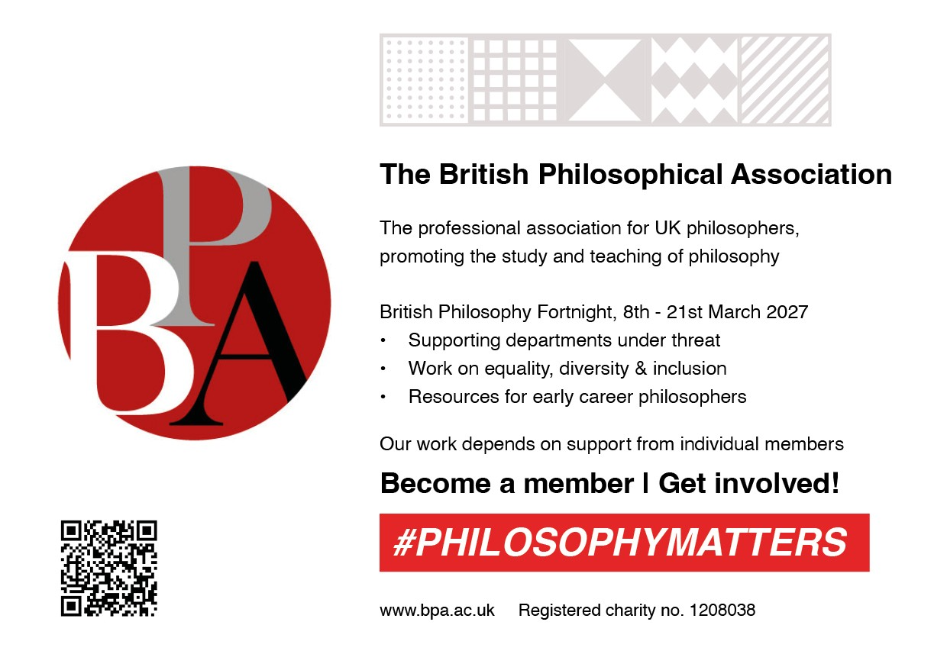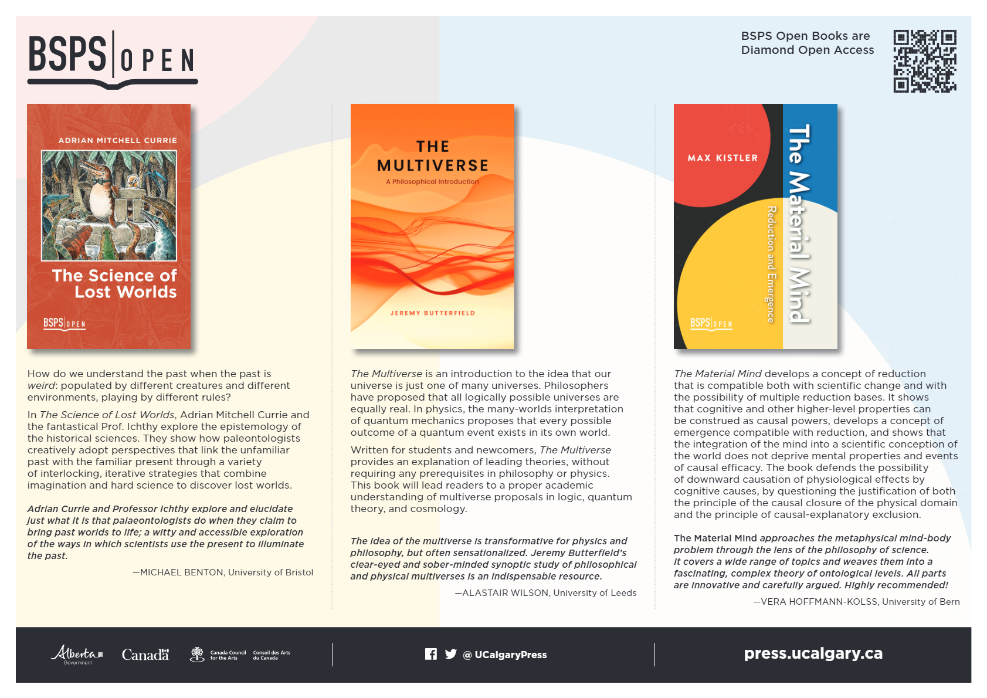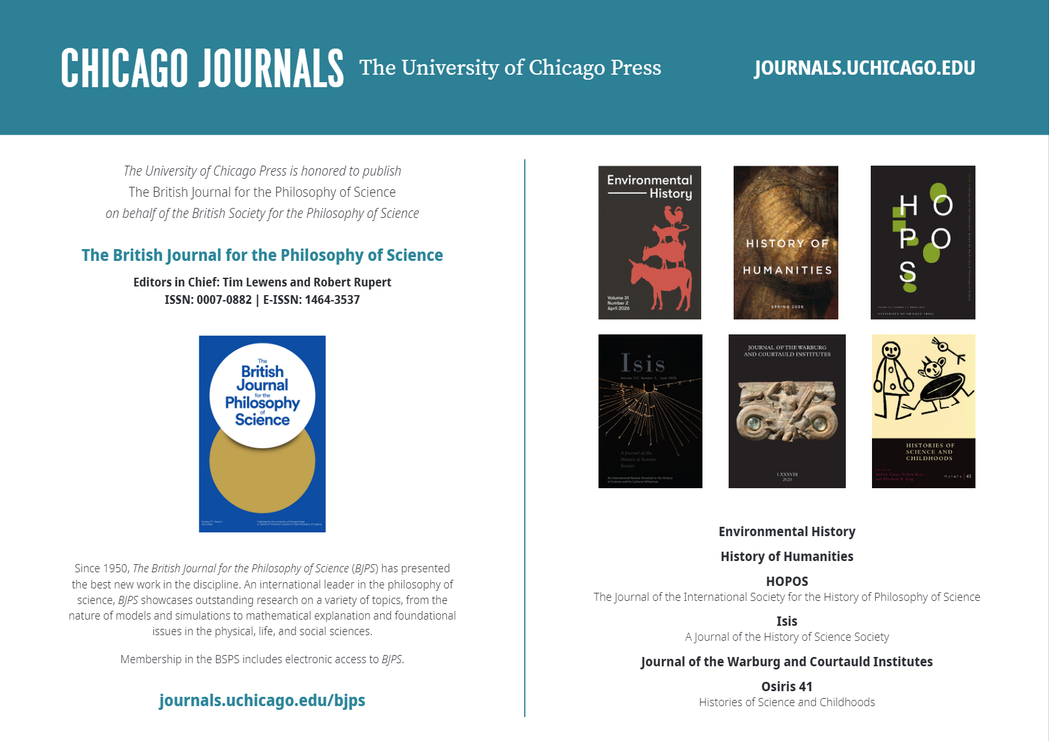

General information

Arrival information

Travel to Leeds: The University's travel info page is here.

Getting to campus: If you come by train, it's about a 20-minute walk to Storm Jameson Court (the accommodation). A taxi should cost you maybe £7 with Uber or a bit more with a regular cab; follow the taxi signs at the station (Uber pick up from the same place).

Or you can catch a bus, but it's a bit of a walk from the station to the nearest bus stop; you want Stop L on Headrow (see the Metro bus stop map). Any bus going to Headingley should have a stop somewhere near the Parkinson Building (the University's main building), e.g. 23, 24, 27, 28, X84, which is a few minutes' walk from Storm Jameson (accommodation) and Maurice Keyworth (conference venue). Or you can catch the 56 from Headrow K, which will take you on to the Maurice Keyworth (Business School), the conference venue. You can pay by contactless; it's a flat fare of £2.50.

If you're coming to Leeds by bus/coach, the above buses all start at the bus station.

Parking: There is no public parking on campus during working hours, so you will need to get in touch with us at least a week in advance (bsps26@leeds.ac.uk) so we can organise a parking permit for you. This will cost you £7/day. The nearest free on-street parking will probably be on the residential streets just north of Woodhouse Moor. Leeds also has a Park and Ride scheme with free parking.

Accommodation:

If you booked your accommodation through us, you're staying at Storm Jameson Court; see Locations. Check-in is from 2pm at Storm Jameson; reception is open 24 hours. Storm Jameson Court check-out is 10am.

At the conference

In an emergency: If you're on campus, for medical, police or fire emergencies call 999 (if appropriate) and then Campus Security on 0113 343 2222 (open 24 hours). There is a defibrillator in Maurice Keyworth by reception that can be accessed between 08:30 – 18:00. If the emergency is outside of these hours, your next closed defibrillator is Henry Price Residences, just outside of the main entrance.

The nearest Accident & Emergency (A&E) is at Leeds General Infirmary -- less than a mile away -- in the Jubilee Wing. For non-emergency first-aid incidents, call Campus Security's non-emergency number, 0113 343 5494.

Chairing policy: Please read this even if you are not chairing any sessions! https://sites.google.com/view/bsps2026/chairing-policy

Handouts and presentations: If the speaker has made a handout or sent us their presentation, you will find it at https://tinyurl.com/bsps-handouts

Breakfast:

If you booked accommodation via the Online Shop, breakfast is included. You will be given a voucher/token for each breakfast when you check in to Storm Jameson. It is served in the Refectory in the Leeds Union Building (see Locations) -- self-service, continental and/or cooked -- from 7.30 to around 10.45.

Dinner on Tuesday:

We'll leave you to make your own arrangements; there are very many food options in the city centre, within a 15-minute walk of campus. If you don't have any better ideas, at least one of us (Helen) will definitely be at the Nation of Shopkeepers from about 8pm (after the wine reception) till late -- on Cookridge Street, about a 20-minute walk from Maurice Keyworth (Storm Jameson is more or less en route). We'll be out in the beer garden if the weather is nice. Serves decent pub grub.

Conference dinner (Wednesday):

This is at 7pm at Akmal's, just across the park from Maurice Keyworth; see locations. The food will be vegan. If you didn't pay for wine, we trust you not to drink any :) You will be able to buy your own drinks.

Cafes:

There's a Caffe Nero in the main conference venue, which should be open during the day. There is a coffee and cake stall in the Refectory (where breakfast is); and there are several cafes, restaurants and takeaways on Woodhouse Lane/Blenheim Terrace, across the street from the University's main building (Parkinson Building).

Shops:

There is a small Co-op in the Union Building, which should be open 8am-9pm, and the LUU shop, selling stationery etc.

Bars:

There will be people at the Nation of Shopkeepers on Tuesday night (see Dinner on Tuesday above). The Old Bar in the Union Building should be open till midnight. The Fenton on Woodhouse Lane is the closest pub to Storm Jameson (cheap, old-school, has a 'beer garden' (back yard) and a pool table). There's also the Dry Dock a bit further down towards town, which is, er, a boat on land. Hard to miss.

Quiet room:

Available 9.30am -- 6.00pm, Tuesday to Thursday: Clarendon Building, room 1.03. This is just across the courtyard behind the conference reception area; first floor.

Internet access:

Eduroam is available across campus. Login instructions for non-Eduroam users will be available at the conference reception desk.

Accommodation check-out: Storm Jameson Court check-out is 10am.

WhatsApp group:

Feel free to join the conference WhatsApp group -- often the quickest way to get help if you've left your laptop somewhere or you're lost on campus or you want to share a taxi to the station, etc. Click here or scan this code



Conference Locations

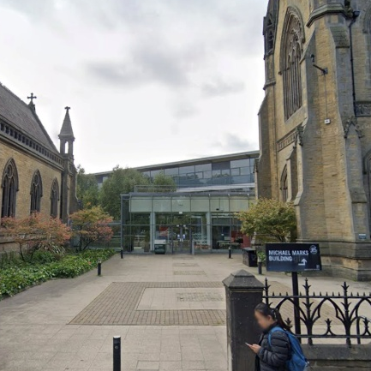 | 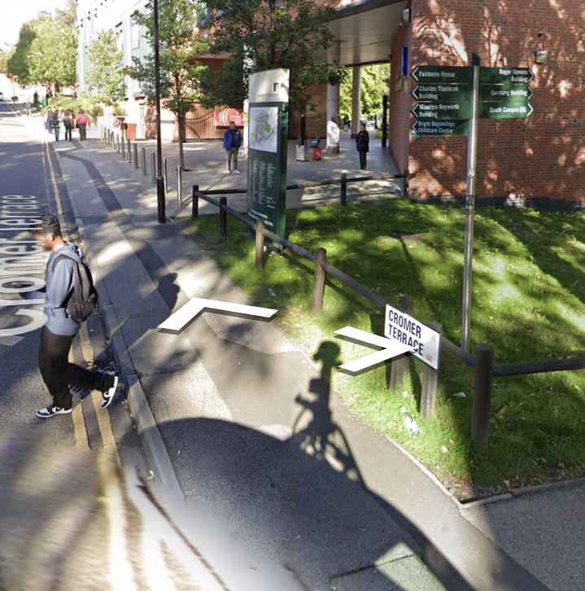 | 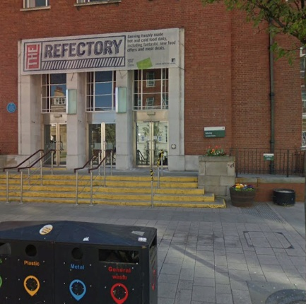 | 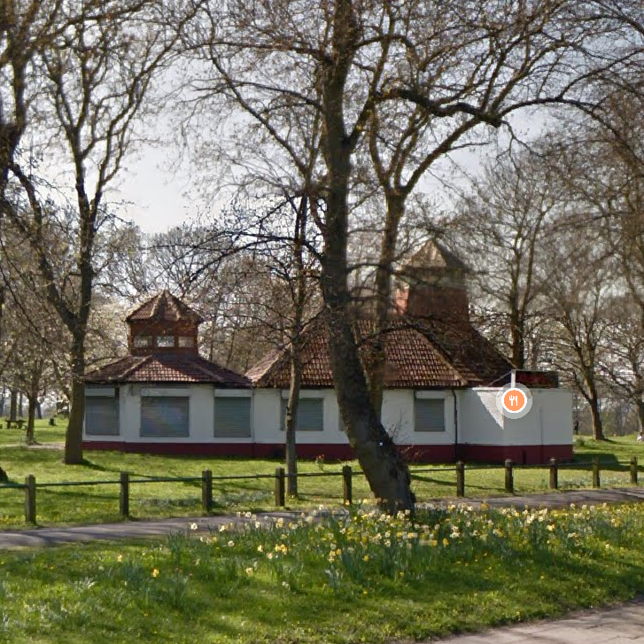
Maurice Keyworth Building | Storm Jameson Court | Refectory | Akmal's Tandoori Bistro
Reception desk/talks/  lunches/tea/coffee/wine reception | Accommodation | Breakfast | Conference dinner
Maurice Keyworth Building,  Moorland Rd,  Woodhouse,  LS6 1AN | Cromer Terrace/Mount Preston St,  Woodhouse,  LS2 9JP | Student’s Union,  Precinct,  Woodhouse,  LS2 9JT | 235 Woodhouse Ln,  Woodhouse,  LS2 3AP

Information for speakers
If you would like a handout, or to make your Powerpoint (etc.) available, please email it to us (bsps26@leeds.ac.uk) by Monday 20 July. Word and Powerpoint are best for accessibility purposes, but pdfs are also OK if necessary. Talk materials will appear here.
Please make sure you stick to time! This is especially important in the contributed-paper sessions, where you have 20 minutes; the chair may cut you off if you go on too long.

Symposium and contributed-paper session speakers, please:
- arrive early, and with your presentation (if you have one) on a memory stick or Dropbox or similar; and ensure that it's downloaded onto the PC before the session starts;
- read the Chairing Policy page (https://sites.google.com/view/bsps2026/chairing-policy);
- For contributed-paper sessions, attend the whole session that you're part of. This guarantees an audience for all the speakers and will generally make for a smooth-running session.
- For symposia, note that the symposiasts are collectively responsible for deciding how to divide up the allotted time between talks and Q&A, and for managing this in the session.

Accessibility information

The University's accessibility information for visitors is here. If you require Blue Badge parking, you will need to get in touch with us (bsps26@leeds.ac.uk) at least several days in advance so that we can organise a parking permit for you; there are disabled parking bays by Maurice Keyworth (the conference venue) and Storm Jameson Court (the accommodation), and the conference dinner venue has a car park.
Full accessibility information: Storm Jameson / Maurice Keyworth / Union Building (breakfast in the refectory)
If you are hard of hearing:
- G.02 has a built-in induction loop system. Switch your hearing aid or cochlear implant to the 'T' (Telecoil) setting to connect directly to the audio feed.
- The seminar rooms have an infrared assistive listening system. Because this relies on infrared line-of-sight transmitters, your hearing aid will not pick up the signal automatically by just switching to the 'T' setting. You will need a portable neck-loop receiver to bridge the signal to your device. You can collect a receiver on-site by asking at the building's Main Reception Desk on the ground floor by Caffe Nero (not the conference reception desk).

Presidential Address

21st July 2026

Robin Hendry (Durham University): Metaphysics and Science: A Call for History

Scientists and philosophers down the ages have argued that there should be no overlap between science and metaphysics. Others have claimed, to the contrary, that science needs a foundation that only metaphysics can provide. I would challenge both these lines of thought, but the first is the main target of this talk.
Consider the following claims, which are widely accepted:
- The Universe was created in a great explosion whose effects remain visible;
- Biological species are the product of a chancy process involving mutation and natural selection;
- What happens in our minds is the outcome of neural processes.
Not only are these all metaphysical (in a broad sense): scientific research is also relevant to them, even if they aren’t simple to decide.
If we understand metaphysics broadly to be concerned with general and abstract questions of existence and reality, science is clearly concerned with metaphysics. But how good is science at answering metaphysical questions like these, and under what conditions? I address that question historically, by looking at two well-known failures (causal determinism and Newtonian mechanics; a claimed refutation of vitalism); and some important but neglected successes (the achievements of 19th-century chemistry).
I conclude by arguing that metaphysical claims can be supported by science if they have had an active, intimate and indispensable heuristic and conceptual role in the development of science. Otherwise, it’s too soon to tell.

Keynotes

22nd July 2026

Tarja Knuuttila (University of Vienna): Revisiting artefactualism: the model-target coupling displaced

Models are epistemic artefacts, constructed and put to many uses, including understanding, prediction, data mining, and design. In many cases, the key to their epistemic value is erotetic: they are built to address pending theoretical or empirical questions, and that is where their epistemic value lies, not in a model’s correspondence to a determinable real-world target system. I defend this thesis and dispel a double bind in the account’s recent reception. It has been claimed, on the one hand, that the artefactual account is covertly representational and, on the other hand, that as a non-representational account, it cannot supply the content that property attribution and model-world comparison require. These charges pull in opposite directions and cannot both land. The artefactual account does attribute content to models, located in the interpreted representational modes and media used in their construction, but does not assume that the epistemic value of models is due to the representational relationship between model and target. Artefactualism stays neutral between different theories of representation, though closer to deflationary, inferentialist accounts. No longer organised around the model-target relation as its unit of analysis, the account clarifies the use of cross-domain model templates, the modal reach of modelling, and models without determinable targets, such as large language models and synthetic models.

23rd July 2026

Eleanor Knox (King's College London): The Scale and Context-relativity of Spacetime Structure

Many theories of quantum gravity appear to imply that the spacetime of general relativity will be effective or emergent. This talk explores the consequences of such a view, and argues that, on any plausible account on which general relativistic spacetime emerges, other relativistic and non-relativistic spacetime structures will emerge in relevant contexts and at relevant scales. This has surprising and under-appreciated consequences – for example, that, at certain scales, binary black holes live in Newtonian spacetime.

Notes

